

Login.gov Partnerships CRM
Technical Design
Template Version 1.04 — Date Issued: January 17, 2019
Document prepared 18 August 2026

1 - APP REVISION HISTORY
This section records changes to the application. At a minimum, links to Jira or ServiceNow tickets provide the best information.
Revision Number | Revision Date | Summary of Changes | Technical Lead
1.00 | 18 August 2026 | First technical design for this application. Describes the application as built and as packaged in outbound change set LDGCRM_Sprint_1_24 (232 components across 24 metadata types), together with the one-time Airtable data migration that populates it. | [GSA IT to supply]

Archive instructions. Make a copy of this document at the start of the fiscal year and save it in the usual location. Append Technical Design - FY## to the filename of the archived copy. Keep only the current fiscal year's entries in the revision history above.

2 - TABLE OF CONTENTS
To build this table of contents, right-click here and choose Update Field.

3 - PROJECT INFORMATION
Project Title | Login.gov Partnerships CRM (LDGCRM)
Executive Sponsor | [GSA IT to supply]
Application Owner | Login.gov partnership team, GSA Technology Transformation Services [named owner to be supplied]
GSA IT Government Lead | [GSA IT to supply]
Development Lead | [GSA IT to supply]
Business Lines/Groups Impacted | Technology Transformation Services (TTS) — Login.gov. GSA IT Engineering deploy the metadata; GSA IT Operations run the data migration.
Subject Matter Expert Resources | [GSA IT to supply]

The personnel rows are deliberately left as placeholders rather than guessed at. Everything else in this document was read from the application's own metadata or queried from the org. The rows above cannot be, so they are marked in place rather than filled with a plausible-looking answer.

3.1 PROJECT SUCCESS CRITERIA

What is the problem?
The Login.gov partnership team works with federal, state and local agencies that want to use Login.gov as their identity provider. Everything about those relationships — which agencies are interested, what they have signed, which of their applications are live, who to talk to at each one, and what is currently blocking each deal — has been tracked in an Airtable base.
That base has served the team well, and the problem is not that it is disorganised. The problem is what it cannot do:
• It has no record-level security. Everyone with access to the base sees everything in it.
• It sits outside GSA's existing customer data. The agencies in it are the same federal Accounts and the same people are the same Contacts that GSA already holds in Salesforce, recorded a second time and kept in step by hand.
• Its structure can change without warning. A column can be renamed or retyped by anyone who can edit the base, and doing so silently changes what the data means. This has already happened: two columns on Opportunities were converted from linked records to plain multi-select values, which would have quietly discarded 453 values had the migration not been written to detect the change and refuse to run.
• It produces no reporting GSA can govern, and it does not appear in GSA's system inventory.

What is needed?
A Salesforce application in the GSA PEO org that becomes the system of record for the Login.gov partnership programme, with the Airtable history carried across in full.
• A single record of each partner agreement, of every application delivered under it, and of the pipeline of agencies not yet signed.
• Those records held alongside GSA's existing federal Accounts and Contacts rather than in a parallel list.
• Record-level security, so that who can see a given partner agreement is a decision GSA makes deliberately and can audit.
• Reporting the partnership team can run without help: pipeline by market segment, revenue blocked by impediment, launches coming up, and applications at risk of missing a launch date.
• The Airtable history migrated rather than re-keyed, with every migrated record traceable back to the exact Airtable row it came from.

How will we know we are finished?
Six specific, checkable criteria.
1. The application is deployed to the production PEO org from change set LDGCRM_Sprint_1_24, and every one of its 232 components verifies against the component inventory issued with it.
2. All nine Flows are active in production, and the org settings the load depends on are in the state described in section 4.6.
3. A full data migration runs in production with zero unexpected failures, and every row not loaded is accounted for by name and reason in that run's report.
4. Every migrated record carries a value in LDGCRM_External_ID__c, so any record in the org can be traced back to its Airtable source row.
5. Members of the partnership team, signed in as themselves rather than as an administrator, can see and edit the records they are meant to and cannot see the ones they are not. This is checked as a non-administrator, because an administrator's own access proves nothing about anyone else's.
6. The reports and dashboards in the Login.gov folders return the same answers the team gets from Airtable today.

3.2 OBJECT MODEL
The application is built from six custom objects and five standard ones. The diagram below is the entity relationship model as built; it distinguishes Master-Detail from Lookup, marks the junction objects, and marks the three lookups that are populated automatically by Flow rather than by a person or by the migration.
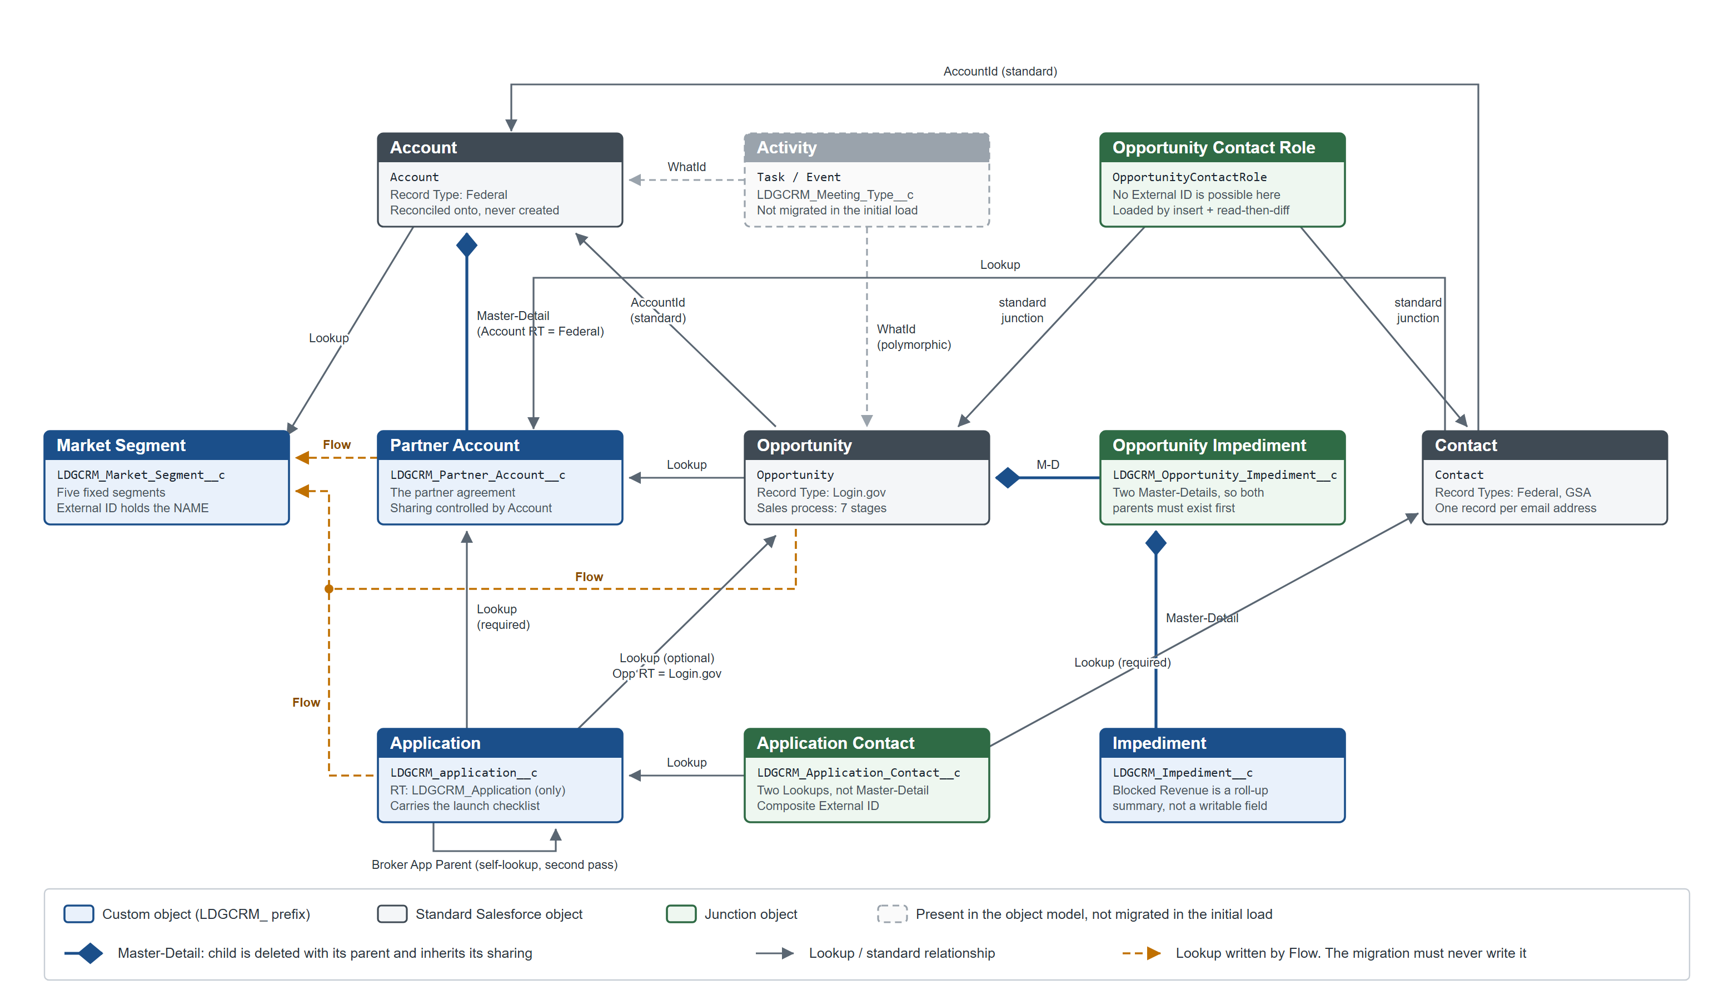
Figure 1. Object model. Read from the object metadata in change set LDGCRM_Sprint_1_24.
Six of the eleven objects are new; the other five are standard Salesforce objects this application adds fields and record types to.
Object | API name | Kind | What it holds
Market Segment | LDGCRM_Market_Segment__c | New | Five fixed segments: Benefits, Defense, Finance & Regulation, Infrastructure, State & Local. Everything else in the model inherits its segment from here.
Partner Account | LDGCRM_Partner_Account__c | New | One partner agreement. Master-Detail child of Account.
Application | LDGCRM_application__c | New | One integration delivered under an agreement. Carries the launch checklist.
Impediment | LDGCRM_Impediment__c | New | A named obstacle, shared across the Opportunities it blocks.
Opportunity Impediment | LDGCRM_Opportunity_Impediment__c | New, junction | Joins an Impediment to an Opportunity, with a severity. Two Master-Details.
Application Contact | LDGCRM_Application_Contact__c | New, junction | Joins a Contact to an Application, and carries the Partner Portal Admin flag. Two Lookups.
Account | Account | Standard | The federal agency. Record type Federal. This application reconciles onto existing Accounts; it does not create them.
Contact | Contact | Standard | A person at an agency, or at GSA. Record types Federal and GSA.
Opportunity | Opportunity | Standard | A prospective agreement. Record type Login.gov, with its own seven-stage sales process.
Opportunity Contact Role | OpportunityContactRole | Standard, junction | Who is involved in a deal, and in what role.
Activity | Task / Event | Standard | Meetings and tasks. Two fields are added; no meeting data is migrated in the initial load.

Three naming defects that are now permanent
These are in the shipped API names. They cannot be corrected without breaking every reference to them, so they are documented rather than fixed. Anyone writing a query, a report or a script against this application has to reproduce them exactly.
• LDGCRM_contact__c on the Application Contact junction has a lower-case c in contact.
• LGDCRM_P3_Partner_Portal_Admin__c on the same object has a transposed prefix, LGDCRM_ rather than LDGCRM_.
• Three of the nine Flows carry the same transposed LGDCRM_ prefix, and one of those three is named ..._Before_Save_... while its trigger is in fact after save. This is a naming inaccuracy only; the behaviour is correct.
The transposed prefix has a practical consequence worth knowing before writing any query that enumerates this application's components: LIKE 'LDGCRM%' misses three Flows, and LIKE '%DGCRM%' matches neither prefix reliably. Run both patterns.

3.3 HIGH LEVEL SYSTEM PROCESS FLOW
The business process the application supports runs in two phases, with a set of records maintained alongside both.
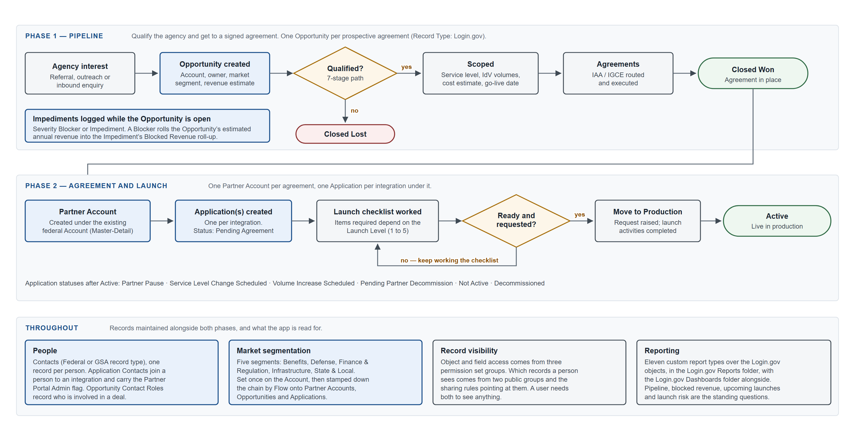
Figure 2. High-level system process flow.
Phase 1, the pipeline. An agency's interest becomes an Opportunity on the Login.gov record type, which moves through a seven-stage sales process: Prospecting, Identified, Qualified, Scoped, Agreements, and then either Closed Won or Closed Lost. While it is open, obstacles are recorded as Impediments joined to it, each with a severity of Blocker or Impediment. A Blocker causes that Opportunity's estimated annual revenue to be counted in the Impediment's Blocked Revenue roll-up, which is how the team answers "what is the most expensive thing standing in our way".
Phase 2, agreement and launch. A Closed Won Opportunity produces a Partner Account: the agreement itself, held as a Master-Detail child of the agency's existing federal Account. One Application is created per integration delivered under that agreement, starting at status Pending Agreement. Each Application then works through a launch checklist whose required items depend on its Launch Level, from 1 (Very Low Impact) to 5 (Very High Impact). When the checklist is done and the partner has asked to go live, the Application moves to Move to Production Request and then to Active. Seven further statuses cover what happens afterwards, from Partner Pause to Decommissioned.
Throughout. Contacts are held once per person, not once per relationship, and are joined to Applications through the Application Contact junction and to Opportunities through Opportunity Contact Role. Market segment is set once on the Account and stamped automatically down the chain. Record visibility is delivered by permission set groups and sharing rules working together, described in section 4.3.

4 - FUNCTIONALITY
This document describes only what is in production. Earlier iterations are not included.

4.1 PROCESS AUTOMATION
The application contains no Apex. There are no triggers, no classes, no batch jobs and no scheduled jobs belonging to it. All of its automation is nine record-triggered Flows, and all nine are declarative.
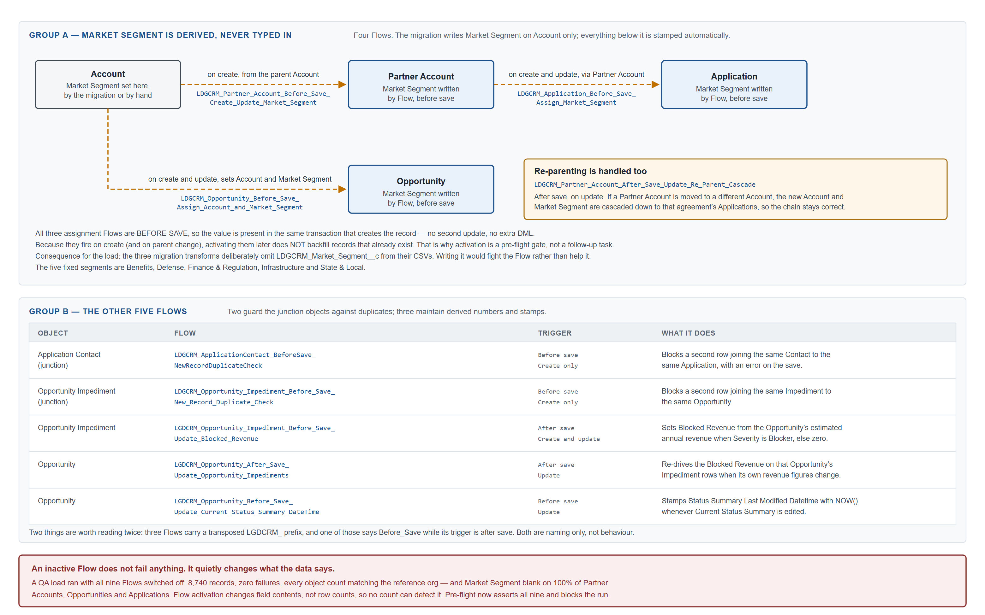
Figure 3. Process automation. The nine record-triggered Flows, grouped by what they are for.
The nine divide cleanly into three purposes.
Four Flows derive Market Segment down the object hierarchy. Market Segment is set on the Account, by hand or by the migration, and is never typed in anywhere below that. Three before-save Flows copy it onto the Partner Account, the Opportunity and the Application as those records are created or re-parented, and a fourth cascades the change if a Partner Account is later moved to a different Account. Because they are before-save, the value is present in the same transaction that creates the record: no second update and no extra DML.
Two Flows guard the junction objects against duplicate rows. Application Contact and Opportunity Impediment each have a before-save Flow that blocks a second row joining the same pair. Both fire on create only.
Three Flows maintain derived numbers and stamps on Opportunity and Opportunity Impediment: Blocked Revenue when severity is Blocker, a re-drive of that figure when the parent Opportunity's revenue changes, and a timestamp on the Opportunity's status summary whenever it is edited.
Flow | Object | Trigger | What it does
LDGCRM_Partner_Account_Before_Save_Create_Update_Market_Segment | Partner Account | Before save, create | Sets Market Segment from the parent Account.
LDGCRM_Opportunity_Before_Save_Assign_Account_and_Market_Segment | Opportunity | Before save, create and update | Sets Account and Market Segment.
LDGCRM_Application_Before_Save_Assign_Market_Segment | Application | Before save, create and update | Sets Market Segment via Partner Account to Account.
LDGCRM_Partner_Account_After_Save_Update_Re_Parent_Cascade | Partner Account | After save, update | Cascades a new Account and Market Segment to that agreement's Applications when the Partner Account is re-parented.
LDGCRM_ApplicationContact_BeforeSave_NewRecordDuplicateCheck | Application Contact | Before save, create | Blocks a second row joining the same Contact to the same Application.
LDGCRM_Opportunity_Impediment_Before_Save_New_Record_Duplicate_Check | Opportunity Impediment | Before save, create | Blocks a second row joining the same Impediment to the same Opportunity.
LGDCRM_Opportunity_Impediment_Before_Save_Update_Blocked_Revenue | Opportunity Impediment | After save, create and update | Sets Blocked Revenue from the Opportunity's estimated annual revenue when severity is Blocker.
LGDCRM_Opportunity_After_Save_Update_Opportunity_Impediments | Opportunity | After save, update | Re-drives Blocked Revenue on that Opportunity's Impediment rows when its revenue figures change.
LGDCRM_Opportunity_Before_Save_Update_Current_Status_Summary_DateTime | Opportunity | Before save, update | Stamps Status Summary Last Modified Datetime with NOW() when the status summary is edited.

An inactive Flow is invisible to every check that counts records
This is the single most important operational fact about the automation, and it is recorded here because it has already caused a failure that looked exactly like a success.
A full data migration ran into the QA sandbox with all nine Flows switched off. It loaded 8,740 records, reported zero failures, withheld nothing, and matched the reference org's record count on every object. It was also wrong: Market Segment came out blank on every Partner Account, every Opportunity and every Application in the org. Flow activation changes field contents, not row counts, so no count-based check can detect it.
Two consequences follow, and both are now built into the pipeline:
• The load's pre-flight asserts that all nine Flows are active and blocks the run if any is not. The check queries FlowDefinitionView in the target org rather than trusting the change set, because a Flow can be Active in an outbound change set and land in the target as Draft. All nine did exactly that on their first deployment to QA.
• Activating a Flow afterwards does not repair records that already exist. The three assignment Flows fire on create and on parent change, and the migration upserts, so re-running the load is an update that does not re-trigger them. An environment loaded with the Flows off has to be reset and reloaded, not patched.

4.2 CONFIGURATION DETAILS

App Setup
One Lightning app: Login.gov Partnerships CRM (LDGCRM_Login_Gov_CRM_App). Standard navigation, both large and small form factors, brand header colour #0070D2, logo from the login2 content asset, home page LDGCRM_Home_Page. Its description in the org reads "Customer Relationship Management for the GSA/TTS Login.gov Program".
This document covers only that app. The PEO org hosts other applications, notably TTS OTCRM and FCIC; components belonging to them are called out explicitly wherever they matter to this one.

Tab Setup
Ten navigation items, in this order: Market Segments, Accounts, Partner Accounts, Opportunities, Applications, Contacts, Impediments, Events, Reports, Dashboards.
Four are new custom tabs (LDGCRM_Market_Segment__c, LDGCRM_Partner_Account__c, LDGCRM_application__c, LDGCRM_Impediment__c). The rest are standard. The two junction objects have no tab of their own by design; they are reached through their parents' related lists.

User Profile(s)
No application permission is granted at profile level. Access to this application is delivered entirely by permission set group, per GSA convention. No new profile is created.
Profile | Permissions
GSA Standard Salesforce User | Existing profile, used unchanged. Nothing in it is specific to this application.
GSA Standard Basic User | Existing profile, used unchanged.
GSA Standard Platform User | Existing profile, used unchanged.
GSA System Administrator | Existing profile. Administrators are assumed to have full access to the application and its data.

All four appear in the change set because a change set carries profile components when object and field permissions are packaged alongside them. A deployed profile is merged into the target's profile, not substituted for it, so permissions already present in the target survive the deployment. That is the intended behaviour here, but it does mean a profile cannot be used to remove an existing permission.

Permission Set(s)
Three permission sets, each wrapped in a permission set group of the same name. People are assigned to the group, not to the bare permission set, so that the org-wide "hide Salesforce Classic" set travels with it.
Permission set group | Key permissions
LDGCRM - G - Partnership Team Member - CRE  Contains LDGCRM_Partnership_Team_Member_CRE and OrgWide_Hide_Salesforce_Classic_System | Assigned app: Login.gov Partnerships CRM.  Account: CRE. Contact: CRE. Opportunity: CRE. Partner Account: CRE. Application: CRE. Impediment: CRE. Market Segment: CRE. Application Contact: CRED. Opportunity Impediment: CRED.  No View All or Modify All.  325 field permissions.
LDGCRM - G - Partnership Viewer - R  Contains LDGCRM_Partnership_Viewer_R and OrgWide_Hide_Salesforce_Classic_System | Assigned app: Login.gov Partnerships CRM.  Read on all nine objects.  View All on Account, Contact and Market Segment.  245 field permissions.
LDGCRM - G - Production Support - CRED  Contains LDGCRM_Production_Support_CRED and OrgWide_Hide_Salesforce_Classic_System | Assigned app: Login.gov Partnerships CRM.  CRED on all nine objects.  Modify All and View All on Market Segment.  324 field permissions.

Delete is granted narrowly and deliberately. The team member set can delete only the two junction rows — joining the wrong Contact to an Application is an ordinary mistake to undo, whereas deleting a partner agreement is not. Full delete belongs to production support.
Record type visibility differs between the three in one place: the team member and production support groups grant Contact.GSA as well as Contact.Federal; the viewer group grants only Contact.Federal. If a viewer needs to see GSA-employee Contacts, that is the line to change.

Custom Permissions
Custom Permission Name | System Name
N/A

Public Groups & Queues
Public groups:
Label | System Name | Description
LDGCRM Team Members | LDGCRM_Team_Members | Users with read/write access to LDGCRM records. Includes managers above a member in the role hierarchy.
LDGCRM Viewers | LDGCRM_Viewers | Users with view-only access to LDGCRM records. Includes managers above a member in the role hierarchy.

Queues:
Label | System Name | Description
N/A

The group definitions deploy; their membership does not. A change set carries a group as an empty shell. After deployment the sharing rules exist, reference real groups, and grant access to nobody. Nothing errors, and the application simply looks empty to everyone who is not an administrator. Populating both groups is a named post-deployment step in the deployment plan.

Sharing Rules
Fourteen rules, all granting to the two public groups above.
Object | Rule | Kind | Access | Shared with
Account | LDGCRM_Account_Federal_Record_Type_R | Criteria: record type is Federal | Read | LDGCRM Viewers
Account | LDGCRM_Account_Federal_Record_Type_R_W | Criteria: record type is Federal | Edit | LDGCRM Team Members
Contact | LDGCRM_Contact_Federal_GSA_R | Criteria: record type is Federal or GSA | Read | LDGCRM Viewers
Contact | LDGCRM_Federal_and_GSA_R_W | Criteria: record type is Federal or GSA | Edit | LDGCRM Team Members
Opportunity | LDGCRM_Opportunity_Federal_R | Criteria: record type is Login.gov | Read | LDGCRM Viewers
Opportunity | LDGCRM_Opportunity_Federal_R_W | Criteria: record type is Login.gov | Edit | LDGCRM Team Members
Application | LDGCRM_Application_All_R | Owner: LDGCRM Team Members | Read | LDGCRM Viewers
Application | LDGCRM_Application_All_R_W | Owner: LDGCRM Team Members | Edit | LDGCRM Team Members
Application Contact | LDGCRM_Application_Contact_All_R | Owner: LDGCRM Team Members | Read | LDGCRM Viewers
Application Contact | LDGCRM_Application_Contact_All_R_W | Owner: LDGCRM Team Members | Edit | LDGCRM Team Members
Impediment | LDGCRM_Impediment_All_R | Owner: LDGCRM Team Members | Read | LDGCRM Viewers
Impediment | LDGCRM_Impediment_All_R_W | Owner: LDGCRM Team Members | Edit | LDGCRM Team Members
Market Segment | LDGCRM_Market_Segment_All_R | Owner: LDGCRM Team Members | Read | LDGCRM Viewers
Market Segment | LDGCRM_Market_Segment_All_R_W | Owner: LDGCRM Team Members | Edit | LDGCRM Team Members

Partner Account and Opportunity Impediment have no sharing rules, correctly: both are Master-Detail children and inherit their parents' sharing.
Section 4.3 explains why the six criteria rules are the ones doing the work and the eight owner rules currently have no effect.

Hierarchy Considerations
The application defines no role hierarchy of its own and depends on none. It does depend on the org's existing hierarchy in one respect: both public groups are defined with Grant Access Using Hierarchies on, so a person above a group member in the role hierarchy inherits that member's access to these records. If that is not wanted for partner agreement data, it is a property of the two group definitions, not of the sharing rules.

Team Roles
N/A. Neither Sales Teams nor Case Teams are used.

Workflows & Processes
Nine record-triggered Flows, listed in full in section 4.1. There are no workflow rules, no Process Builder processes, no approval processes, no batch Apex and no scheduled jobs.

Approvals
Object | Approval Name
N/A

Reports & Dashboards
Report folder: Login.gov Reports (LDGCRM_Reports). Dashboard folder: Login.gov Dashboards (LDGCRM_Login_Gov_Dashboards).
Eleven custom report types, all built over this application's objects:
Report type | Base object
Login.gov Applications with Activities | Application
Login.gov Applications with Application Contacts | Application
Login.gov Applications with Partner Portal Issuer Strings | Application
Login.gov Market Segments | Market Segment
Login.gov Market Segments with Accounts | Market Segment
Login.gov Market Segments with Accounts with Opportunities | Market Segment
Login.gov Market Segments with Accounts with Partner Accounts | Market Segment
Login.gov Market Segments with Partner Accounts with Applications | Market Segment
Login.gov Opportunities with Activity | Opportunity
Login.gov Opportunities with Impediments | Opportunity
Login.gov Partner Accounts | Partner Account

Fourteen list views ship with the application: All Login.gov Accounts; All Contacts and All Accounts; All Applications, Upcoming Launches and Recently Launched; All Impediments; All Market Segments; All Partner Accounts; All Opportunities, All Login.gov Opportunities and Top Login.gov Opportunities.

Validation Rules
One validation rule is packaged with this application.
Rule | Object | Status and effect
Level1_and_Level2_account_restrictions | Account | Inactive. Its error condition formula is the literal FALSE, so even if it were activated it would never fire. It is packaged for parity with the source org rather than for effect.

The Account and Opportunity objects in this org carry a further twenty-two validation rules, all beginning TTS_ or referring to account levels. Those belong to TTS OTCRM, not to this application, and are not packaged with it. They are noted here only so that a reader comparing this document against a Setup screen is not surprised by them.

Organization-Wide Email Addresses
Display Name | Email Address | Allowed Profiles
N/A

The application sends no email. There are no email alerts, no templates and no outbound message.

Custom Settings, Metadata Types, and Labels
Name | Type | API Name
N/A | Setting, Metadata, Label

This application defines none. One belonging to another application is relevant to the data migration and is documented in section 4.6: TriggerControls__c, a hierarchy custom setting owned by the FCIC application, whose Contact record the load switches off for the duration of one step and restores afterwards.

4.3 DATA SHARING MODEL
Two independent things decide whether a person can see a record, and a person needs both. A permission set group decides what they may do to an object and its fields. The org-wide default, the public groups and the sharing rules decide which records exist for them at all. Someone holding the permission set group but in neither public group opens an application that looks empty and reports it as broken.
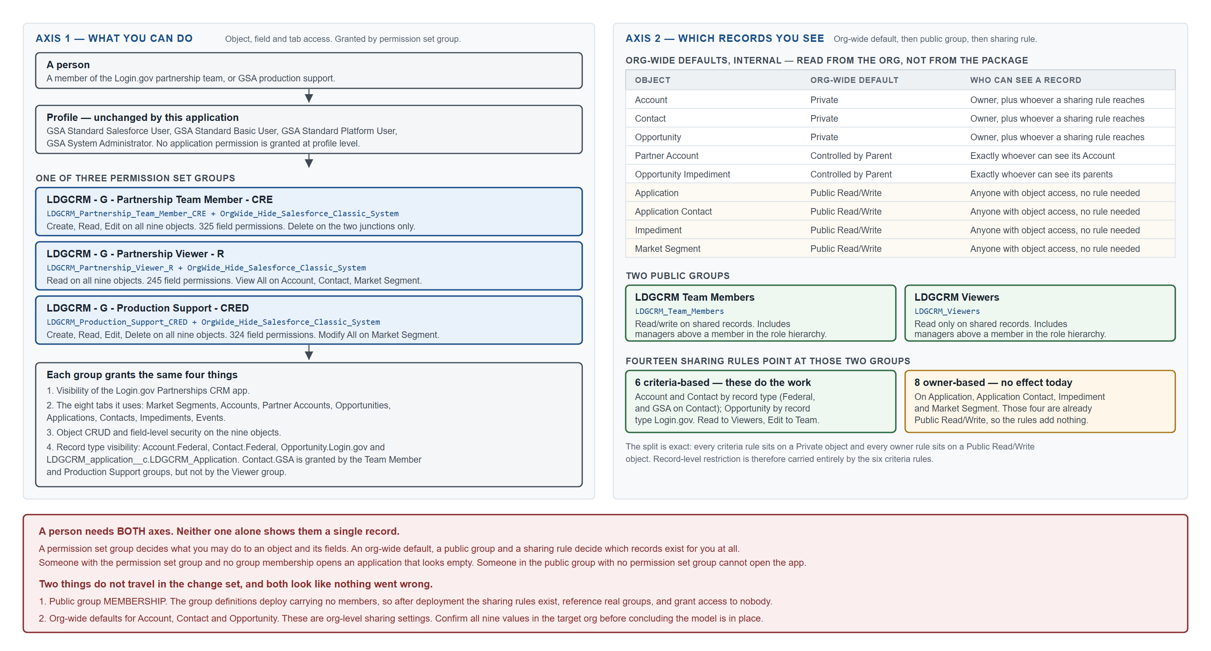
Figure 4. Data sharing model. Org-wide defaults read from the Dev and QA orgs on 18 August 2026.
Object | Default internal access | Who can see a record
Opportunity | Private | Its owner, plus whoever a sharing rule reaches
Account | Private | Its owner, plus whoever a sharing rule reaches
Contact | Private | Its owner, plus whoever a sharing rule reaches
Partner Account | Controlled by Parent | Exactly whoever can see its Account
Opportunity Impediment | Controlled by Parent | Exactly whoever can see its two parents
Application | Public Read/Write | Anyone with object access. No sharing rule is needed or consulted.
Application Contact | Public Read/Write | Anyone with object access.
Impediment | Public Read/Write | Anyone with object access.
Market Segment | Public Read/Write | Anyone with object access.

Sharing rules grant read to LDGCRM Viewers and edit to LDGCRM Team Members for the appropriate record types, as listed in section 4.2. Master-Detail children need no rules of their own.

How the fourteen sharing rules divide
The nine values above were queried from the Dev and QA orgs, not read from the package, and the two agreed exactly. They produce an exact split:
• All six criteria-based rules sit on the three objects whose org-wide default is Private. On those, the rules are the only thing granting access, and they are doing real work.
• All eight owner-based rules sit on the four objects whose org-wide default is Public Read/Write. On those, every user with object access can already read and edit every record, so the rules grant nothing that is not already granted.
Record-level restriction in this application is therefore delivered by the six criteria-based rules on Account, Contact and Opportunity — the objects that carry partner and applicant detail. The four objects with a Public Read/Write default are Application, Application Contact, Impediment and Market Segment. A count of fourteen sharing rules is not a measure of how much of the model is restricted.
Two points bear on this model when it is stood up in a new org:
• Org-wide defaults for Account, Contact and Opportunity are org-level sharing settings and do not travel in the change set. The values for the six custom objects do travel, as part of the object definition. Verify all nine in the target org.
• Public group membership does not travel either. See section 4.2.

4.4 CUSTOM DEVELOPMENT DETAILS
There is no custom code in this application. No Apex, no Lightning Web Components, no Aura components, no Visualforce, no triggers and no callouts. Everything below is declarative configuration. The practical consequence for deployment is that there are no test classes, so the package deploys with a test level of NoTestRun.

Force.com objects (Custom or Standard)

LDGCRM_Market_Segment__c — Market Segment
Label Market Segment / Market Segments. Name field: Text, "Market Segment Name". Org-wide default Public Read/Write. Feed tracking on. Field history on. One custom field, LDGCRM_External_ID__c.
This object's external ID holds the segment name, for example Benefits, not an Airtable record ID. It is the single deliberate exception to the external ID convention used everywhere else in the migration, taken because the set is five fixed, human-meaningful values and the Account reconciliation resolves a segment by matching that name. Compact layout: Custom_Compact_Layout. Record page: LDGCRM_Market_Segment_Record_Page.

LDGCRM_Partner_Account__c — Partner Account
Label Partner Account / Partner Accounts. Name field: Text, "Partner Account Name". Sharing Controlled by Parent. Field history on. Fourteen custom fields.
Master-Detail to Account through LDGCRM_Account__c, filtered to the Federal record type. Carries the agreement's identity and health: LDGCRM_Agreement_Short_Name__c, LDGCRM_Initial_Agreement_Date__c, LDGCRM_Status__c (Active - With Live Applications, Active - But No Live Applications, Inactive), LDGCRM_Service_Type__c, LDGCRM_Partner_Account_Health__c, LDGCRM_Partner_Account_Priority__c, LDGCRM_Partner_Account_Complexity__c, an owner lookup to User, two URL fields, and a 131,072-character LDGCRM_Current_Status_Summary__c.
LDGCRM_Market_Segment__c is written by Flow. The migration must never populate it. Layout: Partner Account Layout. Record page: LDGCRM_Partner_Account_Record_Page.

LDGCRM_application__c — Application
Label Application / Applications. Name field: Text, "Application Name". Org-wide default Public Read/Write. Field history on. Fifty-four custom fields, the largest object in the application. One record type, LDGCRM_Application, which is its only active one. Path: Login.gov Application Path, on LDGCRM_Status__c.
LDGCRM_Partner_Account__c is a required Lookup, so an Application cannot exist without an agreement. LDGCRM_Opportunity__c is an optional Lookup filtered to the Login.gov record type. LDGCRM_Broker_App_Parent__c is a self-lookup used where one brokered application fronts several others.
Most of the object is the launch checklist: around twenty-five checkboxes covering meetings held or waived, surveys completed, approvals given and launch activities done. Six fields are formulas and therefore not writable: LDGCRM_Level_1_Complete_Pct__c, LDGCRM_Level_3_Complete_Pct__c, LDGCRM_Level_4_Complete_Pct__c, LDGCRM_Launch_Checklist_Completion__c, LDGCRM_Annual_Revenue_Amount__c, LDGCRM_Opportunity_Lead__c and LDGCRM_Opportunity_Stage__c. Each declares an ordinary type such as Percent or Text, so the declared type alone does not reveal that Salesforce will reject a direct write.
One property of LDGCRM_Launch_Checklist_Completion__c is load-bearing and is recorded here so it is not later mistaken for a data error: a blank Launch Level falls through its CASE to an else value of 1, so an Application with no Launch Level reports 100% launch-complete. The application owner accepted the formula as it stands. The migration therefore defaults a missing Launch Level to 1 - Very Low Impact, and removing that default would silently return hundreds of Applications to reporting 100%.
LDGCRM_Market_Segment__c is written by Flow. Layout: Application Layout. Record page: LDGCRM_Application_Record_Page.

LDGCRM_Impediment__c — Impediment
Label Impediment / Impediments. Name field: Text. Org-wide default Public Read/Write. Field history on. Five custom fields: LDGCRM_Category__c (a restricted picklist of exactly three values: Product / Feature request, Relationship issue, Issue on partner end), LDGCRM_Description__c and LDGCRM_Talking_Point__c (long text), LDGCRM_External_ID__c, and LDGCRM_Blocked_Revenue__c.
LDGCRM_Blocked_Revenue__c is a roll-up summary over the Opportunity Impediment junction. Salesforce rejects direct writes to it. Layout: Impediments Layout. Record page: LDGCRM_Impediment_Record_Page.

LDGCRM_Opportunity_Impediment__c — Opportunity Impediment
Junction. Name field: AutoNumber, OIID-{00000} — never supply it on a load. Sharing Controlled by Parent. Five custom fields.
Two Master-Detail relationships, to Impediment and to Opportunity, so both parents must exist before a row can be created and the row is deleted if either parent is. LDGCRM_Severity__c is a required picklist of Impediment or Blocker. LDGCRM_Blocked_Revenue__c is a Currency field written by Flow, not by hand and not by the migration. Layout: Opportunity Impediment Layout.

LDGCRM_Application_Contact__c — Application Contact
Junction. Name field: AutoNumber, LDGAC-{0000} — never supply it. Org-wide default Public Read/Write. Seven custom fields.
Two Lookups rather than Master-Detail, which is precisely why this object needs a duplicate-check Flow: a Master-Detail junction would get uniqueness structurally, and this one does not. LDGCRM_contact__c is required; note its lower-case c. LGDCRM_P3_Partner_Portal_Admin__c carries the Partner Portal Admin flag; note its transposed prefix. Three fields are formulas pulled from the related records. Layout: Application Contact Layout.

Account
Record type Federal, an existing record type. Two custom fields: LDGCRM_External_ID__c and LDGCRM_Market_Segment__c (Lookup). Account is the one object in the market segment chain the application writes segment onto directly; every object below it gets its segment by Flow.
This application does not create Accounts. They already exist in the org and represent real federal agencies, most of them predating this work by years. The migration reconciles onto them: matching first by external ID, then by exact name, and writing anything it cannot confidently match to a review file for a person to decide. Compact layouts: Federal_Compact_Layout, LDGCRM_Federal_Account_Compact_Layout. Record page: LDGCRM_Federal_Account_Record_Page.

Contact
Record types Federal and GSA, both existing. Four custom fields: LDGCRM_External_ID__c, LDGCRM_Partner_Account__c (Lookup), LDGCRM_Pronunciation__c and LDGCRM_Subscription_Type__c (multi-select). Layout: LDGCRM Federal Contact Layout. Compact layout: LDGCRM_Federal_Compact_Layout. Record page: LDGCRM_Federal_Contact_Record_Page.
Record type is assigned by where the person works: GSA for anyone with a @gsa.gov address, Federal for everyone else. This application creates only those two and never the FCIC or TTS record types that also exist on the object.

Opportunity
Record type Login.gov (Login_gov), new with this application, with its own seven-stage business process: Prospecting, Identified, Qualified, Scoped, Agreements, Closed Won, Closed Lost. Path: Login.gov Opportunity Path, on StageName. Thirty-one custom fields. Layout: Login.gov CRM. Compact layout: LDGCRM_Opportunity_Compact_Layout. Record page: LDGCRM_Opportunity_Page (dynamic forms enabled).
The revenue model is three fields feeding two formulas: estimated annual IdV users and auth-only users and their average active months produce LDGCRM_Est_Annual_Revenue_fully_ramped__c, which with LDGCRM_Est_First_Year_Ramp__c produces LDGCRM_Est_First_Year_Revenue__c. Both are formulas and neither is writable.
A warning about field selection on this object. Opportunity carries fields from more than one application, and a matching field label is not evidence of ownership. priority_type__c, labelled "Priority Type", belongs to TTS OTCRM and is assigned to the TTS_OTCRM_Opportunity record type. This application's equivalent is LDGCRM_Level_of_Priority__c. Check the LDGCRM_ prefix, not the label. Note also that the three permission sets grant field-level security on priority_type__c, which does not exist in every org — a reference that will fail a change set into any org lacking that field, independently of anything in this application.

OpportunityContactRole
Standard junction. Three custom fields: LDGCRM_Date_Added__c, LDGCRM_Date_Archived__c and LDGCRM_External_ID__c.
LDGCRM_External_ID__c on this object is not flagged as an External ID, and cannot be. Salesforce forbids External ID fields on Opportunity Contact Role entirely; a deploy setting it fails with "Fields on Opportunity Contact Role do not support the property Is External Identifier." There is no metadata fix. The field is populated for traceability only, and this is the one object the migration loads by insert plus read-then-diff rather than by upsert.

Activity (Task and Event)
Two custom fields: LDGCRM_External_ID__c and LDGCRM_Meeting_Type__c. Activity reaches both an Account and an Opportunity through the single polymorphic WhatId; there is no separate custom lookup.
No meeting data is migrated in the initial load, by decision of the application owner. The Airtable meeting history is backed up and is being solved separately. The fields exist so that meetings recorded in Salesforce from go-live onward carry a meeting type.

Lightning Components
N/A. No Aura components and no Lightning Web Components.

Custom Report Types
Eleven. Listed in section 4.2.

Chatter Enabled Objects
Feed tracking is enabled on Market Segment only. It is off on Partner Account, Application, Impediment and both junctions. Feed tracking on the standard objects is an org-level setting this application does not change.

Visualforce Pages
N/A.

Triggers
N/A. This application has no Apex triggers. Two triggers belonging to other applications in the same org do fire on Contact insert and therefore affect the data migration; both are documented in section 5.

Apex Code
N/A. No Apex classes and, consequently, no test classes.

Web Service/API Code
N/A.

Force.com sites
N/A.

Customer Portals
N/A.

Communities
N/A. Nothing in this application is exposed to any external user. "Partner Portal Admin" on the Application Contact junction is a flag describing a person's role in the Login.gov partner portal, an entirely separate system; it grants nothing in Salesforce.

Site.com
N/A.

Third Party Applications
None used by this application. For completeness, the org contains an installed managed package, Genesys purecloud, whose ContactWebHookv1 trigger fires on Contact insert; see section 5.

Other

Paths
Name | Object | Field / Record Type
Login.gov Opportunity Path | Opportunity | StageName, record type Login_gov
Login.gov Application Path | Application | LDGCRM_Status__c, all record types

Global Actions
None.

Lightning Record Pages
Eight FlexiPages: LDGCRM_Home_Page, LDGCRM_Federal_Account_Record_Page, LDGCRM_Federal_Contact_Record_Page, LDGCRM_Opportunity_Page, LDGCRM_Partner_Account_Record_Page, LDGCRM_Application_Record_Page, LDGCRM_Impediment_Record_Page, LDGCRM_Market_Segment_Record_Page.

Sales Processes
One: Login.gov, seven stages, active.

Global Value Sets
One: Demographic_Served, 25 values, shared by Opportunity and Application. It was expanded from 6 values to 25 to hold the range of end-user populations the partner agencies actually record.

Page Layouts and Compact Layouts
Eight page layouts and five compact layouts. Layout assignment is a post-deployment step: a change set carries the layouts but not necessarily their assignment to every profile and record type, so a user can hold every permission and still see the wrong layout.

Content Assets
One: login2, the application logo shown in the Lightning app header.

4.5 SYSTEM INTEGRATION/INTERFACE
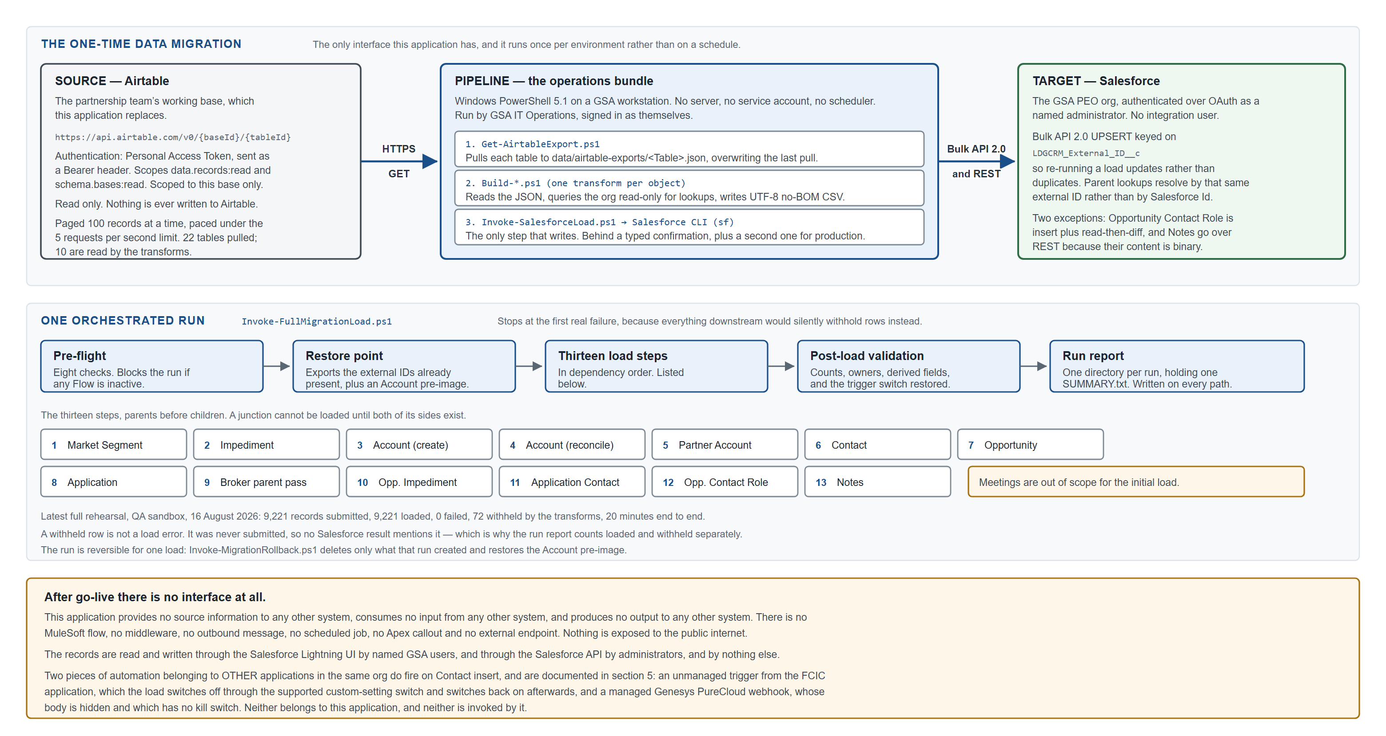
Figure 5. Migration architecture. The only interface this application has, and it runs once per environment.

Will the proposed solution provide source information to other systems?
No. The application publishes nothing. There is no outbound message, no platform event, no Apex callout, no MuleSoft flow, no middleware and no external endpoint. Nothing in it is exposed to the public internet. Its records are read through the Salesforce Lightning UI by named GSA users and through the Salesforce API by administrators, and by nothing else.

What information is needed as an input, and from what system?
One system, once. The Airtable base the partnership team currently works in is the source of the initial data load. It is read over Airtable's REST API (https://api.airtable.com/v0/{baseId}/{tableId}), authenticated with a Personal Access Token sent as a Bearer header, scoped to data.records:read and schema.bases:read and granted access to that base only. The pull is read-only; nothing is ever written back to Airtable. It is paged 100 records at a time and paced under Airtable's five-requests-per-second limit.
Twenty-two tables are pulled so that the pull is a faithful copy of the base. Ten of them are read by the transforms; the other twelve exist so that nothing is lost.
This is not a running integration. There is no scheduled job, no service account and no server. The pipeline is a set of Windows PowerShell scripts run by a named GSA IT Operations engineer from their own workstation, signed in as themselves, with a typed confirmation gate on every step that writes and a second, separate confirmation for production. After the migration is complete the connection to Airtable is simply not used again.

What information will be provided to what systems as an output?
None. MuleSoft is GSA's preferred integration tool for Salesforce integrations, and it is noted here that none is required, because this application has no outputs to integrate.
Should an interface be wanted later — for example to publish launch dates to another GSA system — it would be new work requiring its own design, and MuleSoft would be the expected route.

4.6 DATA MANAGEMENT

What is being loaded
A one-time migration of the Login.gov partnership team's Airtable base into this application, run once per environment. Ten Airtable tables become records across ten Salesforce objects, plus free-text columns that have no field of their own and are carried across as Enhanced Notes attached to their parent record.
Every migrated record carries LDGCRM_External_ID__c holding its Airtable record ID, which is what makes the load idempotent: it is an upsert on that key, so a re-run updates rather than duplicates, and child records reference their parents by the parent's Airtable ID rather than by a Salesforce Id the transform would otherwise have to resolve. There are three deliberate exceptions, each explained in section 4.4: Market Segment keys on the segment name; the Application Contact junction uses a composite <contact>|<application> key; and Opportunity Contact Role cannot have an external ID at all and is loaded by insert plus read-then-diff.

How the conversion is run
Not as a sequence of hand-driven imports in a loading tool. The conversion is one orchestrated run - Invoke-FullMigrationLoad.ps1 - of thirteen steps in dependency order. Each step is a transform that reads the Airtable pull and queries the target org read-only, followed by a load that writes. Nothing writes to Salesforce except the load step, so what would be written can always be read first, as a plain CSV on disk. -PlanOnly executes every transform against the real org and reports what each step would load, without writing anything.
The order is enforced in code rather than left to a human to follow, because getting it wrong does not fail loudly: every transform skips rows whose parent is not in the org yet, so a mis-ordered run produces a smaller migration and a clean-looking summary. The sequence stops at the first failing step and is resumed from a named step once the cause is fixed, rather than re-run from the beginning.
# | Step, and the object it loads | Why it is at this point in the order
1 | MarketSegment  LDGCRM_Market_Segment__c | First. Everything downstream derives its Market Segment from these five records, through the before-save Flows described in section 4.1.
2 | Impediment  LDGCRM_Impediment__c | No lookups, so it can go early.
3 | AccountCreate  Account | Insert. Creates only the Accounts Airtable needs that the org genuinely lacks, and only after sweeping the whole org for a match. Must precede the reconciliation, which tags them.
4 | Account  Account | Update, not upsert. Matches Airtable rows onto Accounts that already exist - including the ones step 3 created - and writes the external ID, Type and Market Segment. It creates nothing.
5 | PartnerAccount  LDGCRM_Partner_Account__c | Master-Detail child of Account, so the parent must exist.
6 | Contact  Contact | Disables the FCIC Contact trigger through that application's own kill switch for the duration of the step, and restores it in a finally block with a verifying re-query.
7 | Opportunity  Opportunity | Must precede Application, which looks up to it.
8 | Application  LDGCRM_application__c | Needs Partner Account and Opportunity.
9 | PopulateBrokerParent  LDGCRM_application__c | Second pass, creates nothing. Fills the self-referential broker-parent lookup on the Applications step 8 has already made; a self-lookup cannot resolve within its own batch.
10 | OpportunityImpediment  LDGCRM_Opportunity_Impediment__c | A junction with two Master-Detail relationships, so both parents must exist.
11 | ApplicationContact  LDGCRM_Application_Contact__c | Junction - needs both sides loaded.
12 | OpportunityContactRole  OpportunityContactRole | Insert plus read-then-diff, never upsert - the one object with no external ID, as noted above. It reads what exists, keys it on Opportunity, Contact and Role, and inserts only what is missing.
13 | Notes  ContentNote | Last. A note attaches to a record that must already exist. Loaded over REST rather than Bulk, because the note body is a binary field the Bulk API rejects.

Every step that writes is gated by a typed token naming what is being approved - -Confirmation "LOAD" for a load, "HARD DELETE" for a reset, "ROLLBACK" for a rollback - rather than by a boolean switch that would read identically on every command. Production requires a second, different token naming the org, so an operator who automated a sandbox run cannot retarget it at production by changing one word. Neither is ever baked into a saved script or a scheduled job: a production migration is a supervised event.

Volumes, from the most recent full rehearsal
QA sandbox, 16 August 2026. 9,221 records submitted, 9,221 loaded, zero failures, 72 rows withheld by the transforms, twenty minutes end to end.
Object | Submitted | Loaded | Withheld
Market Segment | 5 | 5 | 2
Impediment | 37 | 37 | 1
Account (created) | 9 | 9 | 0
Account (reconciled) | 691 | 691 | 0
Partner Account | 99 | 99 | 0
Contact | 1,918 | 1,918 | 33
Opportunity | 904 | 904 | 0
Application | 1,052 | 1,052 | 7
Application, broker parent pass | 69 | 69 | 0
Opportunity Impediment | 311 | 311 | 0
Application Contact | 2,793 | 2,793 | 18
Opportunity Contact Role | 596 | 596 | 11
Notes (ContentNote) | 737 | 737 | 0
Total | 9,221 | 9,221 | 72

A withheld row is not a load failure, and the distinction matters when reading any report of this migration. A withheld row was never submitted: the transform skipped it because a parent had not loaded, or a junction's other side was itself withheld, or a required value was absent in Airtable. Salesforce never saw it, so no load result mentions it. The run report counts loaded and withheld separately for exactly this reason, and the 72 above are itemised by cause in it.
Production figures will differ, and should be expected to. The Airtable base is re-pulled immediately before each load, so counts move as the team's own data moves.

Data quality on initial load
Data quality was worked as a first-class part of the migration rather than accepted as found. The rule applied throughout was that a row is either migrated correctly or withheld and reported by name — never guessed at, and never made to fit by inventing an alias or a default. Several specific decisions are worth recording:
• Accounts are reconciled, not created. 757 Airtable Account rows do not map one-to-one onto the org's Accounts. Matching is by external ID first, then by exact name; anything ambiguous goes to a review file for a person to decide. A large share of the unmatched rows turned out to be duplicates within Airtable itself, such as Army alongside Department of the Army.
• Contacts are merged by email address. Airtable has no person-to-application junction, so the same person appears once per association. 1,599 Airtable rows become 1,532 Contacts.
• A placeholder Impediment named None is excluded deliberately. It carried 465 links, five times any real impediment, and had no description. Loading it would have put a meaningless figure at the top of the Blocked Revenue roll-up.
• Airtable-side rollups are not migrated, because they are not facts. The Partner Accounts table appeared to link to 961 Opportunities; on inspection that column was a roll-up of the parent Account's Opportunities, not an authored relationship. The authored link covers 82 Opportunities, and that is what was migrated.

What the load changes in the org, and what it puts back
The pipeline changes four org settings. Three are permanent and one is restored. Nothing else in the org's configuration is touched, and the pipeline cannot add a field, a picklist value or a record type: where a load is blocked by missing metadata it names the component and stops.
Change | Why | Environments | Restored?
Every active Contact duplicate rule set inactive | OTCRM_Contact_Duplicate matches on first and last name only, both exact. It rejected 167 Contacts on one load. TTS OTCRM, which owns the rule, is defunct. | All, including production | No, permanent
Every active Contact matching rule set inactive | Housekeeping behind the above. A matching rule cannot be deactivated while an active duplicate rule consumes it, so the order is fixed. | All, including production | No, permanent
The nine LDGCRM Flows set active | Without them Market Segment is blank org-wide and the load still reports success. See section 4.1. | Sandboxes only; rejected for production | No, permanent
TriggerControls__c → Contact → On__c set false | FCIC's GSA_FCIC_ContactTrigger creates a junk Account for every Contact inserted with a blank AccountId — 371 of them on a normal run. This is FCIC's own supported switch. | All | Yes, in a finally block, verified by re-query

The first three leave the org in the state it needed to be in anyway; restoring them between runs would reintroduce exactly what they were changed to prevent. The fourth belongs to another live application, so its restore is defensive: the original value is captured before anything changes, restored even if the load throws, verified by re-query, and re-checked independently by post-load validation.
Where Salesforce exposes no record-level write for a setting — as with the duplicate and matching rules — the pipeline retrieves the component from the target org, changes one status element, and deploys it back to that same org. No XML crosses an org boundary, no component is created and no definition is altered.

Reversibility
One load can be rolled back. Invoke-MigrationRollback.ps1 takes a run's directory and deletes only what that run created — measured as the external IDs present in the org afterwards minus those present before, read from the org on both sides rather than from the load files — and restores the Account pre-image rather than deleting, because the migration updates Accounts it does not own.
Undoing an insert is easy; undoing an update is not. The migration updates records that predate it by years: external ID, Type and Market Segment on Accounts, ownership on Opportunities, Applications and Contacts, and parent on Accounts that had none. Only Account has a pre-image. And if people have been working in the org since the load, rolling back destroys their work; fixing forward is then the correct choice.

Ongoing data operations
None. After go-live there is no recurring load, no synchronisation back to Airtable and no scheduled data job. Records are maintained by the partnership team in the Salesforce UI.

Where the conversion procedure is documented
The operational procedure is not in this document, and it is not in the pipeline's own repository notes either. It is section 3.0 of the Technical Deployment Plan, which is the formal, controlled document for conducting the load.
That section is self-contained and needs no other document: machine prerequisites, the environment registry and authentication, Airtable access and the data pull, where files go, the readiness check, the dry run, the pre-flight checks, running the load and its thirteen steps, how record ownership is decided, how to read the run report, the verification queries object by object, and the errors this pipeline actually produces. Undoing a load is section 2.1 of the same document.
The bundle also carries operator notes under docs/, alongside short README files describing what is in data/, data/prod-accounts/ and reference/. Those are a convenience copy for the person at the keyboard and are not the controlled documentation - where they and the Technical Deployment Plan differ, the Plan governs.

4.7 SELF-ASSESSMENT
The rows below are the Force.com security self-assessment's own vulnerability list, in its own order and under its own three groupings. Each is answered for this application.
One fact shapes almost every answer: this application contains no custom code. It has no Apex, no Visualforce, no Lightning components, no callouts, no sites, no communities and no external endpoints. It is declarative configuration over the Salesforce platform, so the platform's own controls are the mitigation in most rows, and there is no application code in which the vulnerability could be introduced.

Client Application Security
Vulnerability | How this design mitigates it
Buffer Overflow | Not applicable. No C/C++ or any native code. The application runs entirely on the Salesforce platform, which manages memory on the application's behalf.
ActiveX Control Security | Not applicable. No ActiveX control is used, shipped or referenced. The application is a Lightning application rendered in a modern browser.
Flash Security | Not applicable. No Flash content of any kind.
Integer Overflows | Not applicable. No custom code performs arithmetic on user input. The only calculations are Salesforce formula fields and Flow assignments, evaluated by the platform within its own numeric limits.
Format String Vulnerability | Not applicable. No custom code, and therefore no format string handling.

Composite Application Security
Vulnerability | How this design mitigates it
Cross Site Request Forgery | Mitigated by the platform. Force.com implements CSRF protection by default, and this application adds no code that performs a database action from a GET request — there is no custom page or endpoint at all.
SQL Injection | Not applicable. There is no SQL and no database the application reaches directly. The migration pipeline issues SOQL through the Salesforce CLI with fixed queries and no user-supplied text concatenated into them.
Cross Site Scripting | Mitigated by the platform. All rendering is by standard Lightning components, which escape output. The application contributes no custom markup, no Visualforce and no JavaScript. Rich text fields are stored and rendered through the platform's own sanitising rich-text handling.
Validating Single Sign on Servers | Not applicable. The application performs no SSO integration of its own. Authentication to the org is GSA's existing enterprise arrangement and is unchanged by this application.
Secure Communications and Cookies | All access is over HTTPS. The migration pipeline's two connections — Airtable's REST API and the Salesforce API — are both HTTPS, and neither the application nor the pipeline sets a cookie.
Flash Security | Not applicable, as above.
OS Command Injection | Not applicable in the application, which has no code. In the migration pipeline the PowerShell scripts invoke only the Salesforce CLI, with arguments bound as parameters rather than assembled into a command string, and are run interactively by an authenticated engineer rather than exposed to any caller.
HTTP Response Splitting | Not applicable. The application constructs no HTTP response and sets no header.
Insecure Direct Object Reference | Mitigated by the platform's sharing model, which is enforced by Salesforce on every record access regardless of how a record is reached. Because there is no custom code, there is no path that could bypass sharing. Section 4.3 documents the model in full.
Session Handling | Handled entirely by the platform. The application creates and manages no session identifier. The migration pipeline authenticates over OAuth through the Salesforce CLI and stores no password.
Injection Flaws | Not applicable, per the SQL and OS command rows above. No interpreter receives user-supplied data from this application.
Failure to Restrict URL Access | Mitigated by the platform. There is no custom page or endpoint to reach. Access to every object, field, tab and record is controlled by permission set group and sharing rule, and enforced by Salesforce on the server rather than by hiding a link.
Storing Secrets | The application stores no secret. The migration pipeline holds an Airtable Personal Access Token in a .env file that is excluded from source control by a .gitignore travelling in the same folder, and the exclusion is verified by an automated structural test. The token is read-only, scoped to two read scopes, and granted to one base.
Denial of Service | Mitigated by the platform, which enforces its own governor limits and request throttling. The application adds no unbounded operation: there is no Apex, no batch job and no scheduled process. The migration is a one-time bulk load run deliberately, not an exposed request path.
Directory Traversal | Not applicable. The application reads and writes no files. The migration pipeline resolves every path from its own bundle root through a single helper rather than accepting a path from input, and this is enforced by an automated structural test.
External Includes | Not applicable. No page in this application includes any external resource; there are no custom pages.
File Upload Vulnerabilities | The only upload path is Salesforce's own Files feature, used by the Enhanced Notes the migration creates. Content is stored and served by the platform, is never executed, and is subject to the same sharing rules as the record it is attached to.
Malicious File Execution | Not applicable. Nothing in this application executes a file, and no uploaded content is interpreted.
Arbitrary Redirects | Not applicable. The application performs no redirect. Its URL fields hold links a user follows deliberately; they drive no automatic navigation.
Abuse Of Functionality | The business logic that could be abused is the automation in section 4.1, all of which is server-side Flow that a user cannot bypass or re-parameterise. Delete rights are granted narrowly: ordinary users can delete only junction rows, and full delete belongs to the production support permission set.
Information Leakage | Mitigated by field-level security and by the record-level model in section 4.3. No debug or error text is generated by this application, because it has no code. The migration pipeline writes logs and review files containing applicant contact details to directories excluded from source control, and that exclusion is verified rather than assumed.
Authentication | Handled entirely by GSA's existing Salesforce authentication. The application creates no login path, no user and no credential, and its migration pipeline authenticates as a named human administrator rather than as a shared integration user.

Native Application Security
Vulnerability | How this design mitigates it
Force.com CRUD, FLS and Sharing | This is the row that matters most for this application, and it is answered in full in section 4.3. With no Apex, CRUD, field-level security and sharing are enforced by the platform on every access and cannot be bypassed by application code, because there is none. Object and field access comes from three permission set groups; record access comes from org-wide defaults, two public groups and fourteen sharing rules. Four objects have an org-wide default of Public Read/Write, which makes the eight owner-based sharing rules on them inert; record-level restriction is carried by the six criteria-based rules on Account, Contact and Opportunity. Section 4.3 sets the model out in full.
Cross Site Scripting | As above. All rendering is by platform components; the application contributes no markup or script.
SOQL Injection | Not applicable in the application, which issues no SOQL. In the migration pipeline every query is written in the script with fixed field and object names; values interpolated into a filter come from the org's own data or from a validated parameter, never from an unauthenticated caller, and the pipeline runs only under an authenticated engineer's own session.
Storing Secrets | As above. No secret in the application; one read-only, base-scoped Airtable token in the pipeline, excluded from source control by a verified rule.
Arbitrary Redirects | Not applicable.
Cross Site Request Forgery | Mitigated by the platform, which implements CSRF protection by default. The application performs no database action from a GET request because it has no custom request handling.
Abuse Of Functionality | As above. Server-side Flows, narrow delete rights, and a migration pipeline that gates every write behind a typed confirmation, with a second and separate confirmation naming the org before anything can be written to production.

5 - CONSIDERATIONS
CONSIDERATION: Custom objects were chosen over standard ones only where no standard object fits. Partner Account, Application, Impediment and Market Segment describe things Salesforce has no equivalent for: a partner agreement, an integration delivered under it, a named obstacle, and a market segmentation of federal agencies. Everywhere a standard object did fit — the agency, the person, the deal, the person's role in the deal, the meeting — the standard object is used and extended with LDGCRM_ fields. That is why Account, Contact, Opportunity, Opportunity Contact Role and Activity appear in a model that is otherwise custom.
CONSIDERATION: Partner Account is Master-Detail to Account, not a Lookup, and that is a security decision as much as a data one. An agreement has no meaning apart from the agency it is with, it should not outlive that Account, and whoever may see the agency should see the agreement. Master-Detail delivers all three, and is why Partner Account needs no sharing rule of its own.
CONSIDERATION: The two junction objects are deliberately different from each other. Opportunity Impediment uses two Master-Details, which makes each pairing unique structurally and cascades deletes correctly. Application Contact uses two Lookups, because an Application Contact row is meaningful in its own right and should survive operations that a Master-Detail would cascade through. The cost of that choice is that uniqueness has to be enforced by a Flow, and that Flow fires on create only and reads committed state, so it cannot see a duplicate inside its own batch. The migration therefore does not rely on it: it makes uniqueness structural by using a composite external ID, <contact>|<application>.
CONSIDERATION: Market Segment is derived rather than entered, and the cost of that is that activation order matters. Deriving it means it cannot drift between a Partner Account and its Account, and it cannot be forgotten on data entry. The cost is that the three assignment Flows fire on create, so a record created while they are inactive keeps a blank segment permanently, and activating the Flows later repairs nothing. This is why Flow activation is a blocking pre-flight check and not a post-deployment tidy-up.
CONSIDERATION: Four objects are openly shared internally, and their owner-based sharing rules are inert as a result. Application, Application Contact, Impediment and Market Segment carry an internal org-wide default of Public Read/Write in both the Dev and QA orgs, so every user with object access can already read and edit every record, and the eight owner-based rules on those objects grant nothing further. Record-level restriction is carried by the six criteria-based rules on Account, Contact and Opportunity, which are the objects holding partner and applicant detail. A count of fourteen sharing rules is therefore not a measure of how restricted the model is.
CONSIDERATION: Two pieces of automation belonging to other applications fire on Contact insert in this org, and neither is in this application's metadata. Reading this application's components carefully would not reveal either of them; both were found by querying the org.
• GSA_FCIC_ContactTrigger, unmanaged, belonging to the FCIC application, creates an Account named after the person for every Contact inserted with a blank AccountId — 371 of them on a normal migration run. FCIC ships a supported switch for it, TriggerControls__c, and the load uses that switch: capture, disable, load, restore in a finally block, verify by re-query.
• purecloud.ContactWebHookv1, an installed managed package from Genesys, also fires on Contact insert. Its body returns (hidden), it cannot be retrieved, and it has no kill switch. What it does is therefore unknowable from inside this application. It was confirmed inert in the Dev sandbox; it should be re-confirmed with the owner of the PureCloud integration before the production load, because a webhook on Contact insert is an outward-facing side effect this application cannot inspect and a bulk load inserts thousands of Contacts at once.
CONSIDERATION: An org-level duplicate rule owned by TTS OTCRM is switched off permanently, in every environment including production. OTCRM_Contact_Duplicate matches on first and last name only, both exact, and rejected 167 Contacts on a single load. It is TTS OTCRM's rule and TTS OTCRM is defunct. Adding an email condition instead of disabling it was investigated and is not possible by change set: Salesforce refuses to modify a matching rule that is active in the target, refuses to change a definition and a status in one deployment, and a change set always carries the source org's status with no way to edit it.
CONSIDERATION: The application deploys with a test level of NoTestRun, and that is a consequence of having no Apex rather than a shortcut. There are no test classes to run because there is no code to test. This is worth stating explicitly because a validation deploy against this org currently fails for an unrelated reason: GSA_FCIC_AC_Manual_InitialBatch, part of the FCIC application, has a genuine compile error, and Salesforce compiles all Apex in an org before running any test. Any deployment that runs tests will fail on that class regardless of what is being deployed. The Technical Deployment Plan states this test level explicitly rather than leaving it to a default.
CONSIDERATION: Meetings are deliberately out of scope for the initial load. Airtable records a meeting date but no time. Loading them as Events would mean synthesising a start and end time, which fabricates scheduling history that looks authoritative in a calendar. The Airtable data is backed up and the meeting history is being solved afterwards, most likely by capturing real calendar events and matching Airtable's meetings onto them rather than inventing new ones. This is not a gate on production.
CONSIDERATION: Three API names are permanently wrong and are documented rather than corrected. LDGCRM_contact__c with a lower-case c, LGDCRM_P3_Partner_Portal_Admin__c with a transposed prefix, and three Flows with the same transposed prefix, one of which is named for the wrong trigger timing. Renaming a field API name breaks every reference to it — formulas, reports, layouts, permission sets, integrations and scripts — for no functional gain. The correct treatment is to write them down where anyone querying this application will see them, which is section 3.2.
CONSIDERATION: Volume is small and will stay small. The application holds on the order of ten thousand records across eleven objects, added to at the pace at which federal agencies sign agreements. No large-data-volume design was needed: no skinny tables, no archiving strategy, no selective-index work. The one bulk operation, the migration itself, runs once per environment and is complete in about twenty minutes.
CONSIDERATION: The audience is small and internal. The application is used by the Login.gov partnership team, by GSA production support, and by whoever above them in the role hierarchy inherits access through the two public groups. There are no external users, no community and no portal. "Partner Portal Admin" refers to a role in the separate Login.gov partner portal, not to any Salesforce access.

6 - Appendix

Where the detail behind this document lives
This document is the technical design. Four other documents carry the operational detail, and are maintained separately so that this one does not go stale every time a number moves.
Document | What it holds
Production change set inventory | Component-by-component listing of LDGCRM_Sprint_1_24: all 232 components across 24 metadata types, with every custom field's type, attributes and description read from the retrieved XML.
Technical Deployment Plan | Pre-deployment steps, deactivation and activation of components, the package itself, post-deployment manual steps, and the rollback procedure.
Release Plan | The GSA release checklist answered for this release.
Operations bundle documentation | Shipped with the migration scripts: what the pipeline migrates, how to set it up, how to run a load, how to read a run, how to troubleshoot one and how to roll one back.
Source repository | The application's metadata, the migration pipeline and the sources for the five diagrams in this document: https://github.com/davidlarrimore/LDGCRM-Salesforce-App. Metadata reaches an org by change set, never from this repository.

How the facts in this document were obtained
Each statement in this document derives from one of three sources.
• Object, field, record type, layout, Flow, permission set, sharing rule, report type and list view detail was read from the application's retrieved metadata, sourced from change set LDGCRM_Sprint_1_24 as built in the Dev sandbox on 17 August 2026.
• Org-wide defaults were queried from the Dev and QA orgs on 18 August 2026, because they are not fully carried by the package. The two orgs agreed on all nine values.
• Migration volumes are from the QA sandbox run of 16 August 2026, the most recent full rehearsal.
• The behaviour of components belonging to other applications in the org — the FCIC trigger, the PureCloud webhook, the OTCRM duplicate rule — was established by querying the org, because none of it appears in this application's metadata.
Nothing in this document was inferred from a component's name or label. Where a name and a behaviour disagree, the behaviour is what is recorded, and the disagreement is noted.

